Antoniette M. Guglielmo

**Machine-Age Exposition (New York, 1927)** **519 words**

The *Machine-Age* *Exposition* took place from 16-28 May 1927 at 119 West 57th Street in Steinway Hall, a commercial space in Manhattan, New York. It exposed the American public to the machine-age aesthetic, a modernist style based upon a belief in technological progress. The style emphasised the qualities of mass production, streamline design, functionality, dynamism, and force. Jane Heap (1883-1964) of the Little Review Gallery was the main organiser, bringing together engineers and artists to rally momentum for this particular strain of modernist art. Significantly, the installation juxtaposed works of architecture, engineering, industrial arts, and high-modernist painting and sculpture in order to emphasise their “inter-relation and inter-influence,” as advertised on the exposition flyer. The *Machine-Age Exposition* highlighted a commonality among these disciplines of exalting the beauty of machinery and celebrating innovation and progress. The exposition celebrated the machine-age aesthetic, as did other exhibitions, most notably *Machine Art* (1929) at the Museum of Modern Art.

The installation underscored the commonalities between high art and industrial innovation, stressing their shared designs and values. It featured photographs, drawings, sculptures, and constructions of the industrial arts and engineering such as various American and European industrial plants, a grain elevator, and a steel gyratory crusher. Juxtaposed to these were actual machine parts such as gears, valves, radio sets, and machine guns. Among them were a Studebaker crankshaft, an I.B.M. time clock, and a Hyde Windlass propeller. The *Exposition* included artworks of renowned European and American modernists. Visual artists who participated included Alexander Archipenko (1887-1964), Charles Demuth (1883-1935), Marcel Duchamp (1887-1968), Louis Lozowick (1892-1973), Man Ray (1890-1976), and Charles Sheeler (1883-1965).

The *Exposition* also featured architecture. The catalogue documents European modern domestic architecture by Walter Gropius (1883-1969), works from the Bauhaus, Russian industrial architecture, and Streamline Moderne American buildings like the fantastic glass skyscraper by Hugh Ferriss (1889-1962) and the Radiator Building by Raymond Hood (1881-1934). Fernand Léger, who wrote, “the machine belongs to the architectural order,” created a machine age abstraction for the cover of the catalogue. A catalogue essay by Enrico Prampolini served as a manifesto. Prampolini proclaimed, “The Machine to be the tutelary symbol of the universal dynamism, potentially embodying in itself the essential elements of human creation: the discoverer of fresh developments in modern aesthetics”.

Jane Heap’s gallery, which was open from 1925 to 1927, was associated with the *Little Review,* an influential art and literary magazine published from 1914 to 1929. Its motto was “Making No Compromise with the Public Taste.” Heap became editor in 1924, after having served as co-editor with her lover and the magazine’s founder Margaret Anderson (1886-1973). Heap interacted in avant-garde circles and promoted modernism—particularly Dadaism, Surrealism, and Constructivism—through the magazine and gallery.

**References and Further Reading**

Heap, J. (ed) (1927)[*Machine-Age Exposition* catalogue](http://digital.hagley.org/cdm/compoundobject/collection/p268001coll12/id/16132/rec/2). New York: Little Review.

Lippmann, Herbert (1927). “The Machine-Age Exposition,” *The Arts* 11 (6): 324-326.

Platt, S. (1989) “Mysticism in the Machine Age: Jane Heap and the Little Review,” *Twenty/One,* *Art and Culture* (Fall): 18-44.

Wilson, R., Pilgrim, D., and Tashjian D. (1986) *The Machine Age in America, 1918-1941.* New York: The Brooklyn Museum and Harry N. Abrams, Inc.

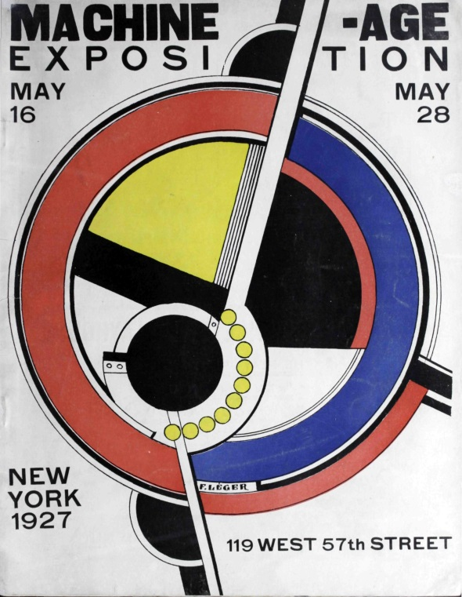

Fernand Léger, cover of the [*Machine-Age Exposition* catalogue](http://digital.hagley.org/cdm/compoundobject/collection/p268001coll12/id/16132/rec/2), 1927.